Segregation in Education: The Racial and Socio-Economic Discrimination Effects
Juan Cardenas
Prof. Aisha Sidibe
ENG110
17 May 2019

Segregation in American education today has existed for a longer time than it may seem, having its roots in the period of slavery and the resultant emancipation of slaves where even though black people were declared free, they still continue to live in conditions that are less than ideal. There is the question of why segregation is wrong, whether it is because it violates the rights of learners to attend any school and thus the democracy of the black minorities or whether it is because it promotes socio-economic inequalities where the schools attended by the minority are underfunded and thus cannot provide a similar quality of education with the schools for the whites, thus resulting in educational inequalities. A review of literature shows that educational segregation in America today carries multiple effects from the psychological effects that segregation has on learners, to the missed opportunities that minority learners have to forego and the reverberating effects this has on their lives.
Ambrose Caliver, (1956), traces the roots of segregation in education in America and finds that educational segregation was one of the futile ways in which white supremacists sought to cling to their supremacist ideologies after the abolishment of slavery in the south. Since they badly needed to feel superior they coined the term, separate but equal to show that black and white people would have separate services but they justified that the services would be equal.
There was no equality however of the separate systems including education as can be seen in figure 1 below where on ones side of the divide is the well-funded and proper school while on the other side of the divide is an example of a black school. Caliver shows that even the highest law of the land, the constitution that was used in determining that black and white people maintain separate services in the Plessy versus Ferguson case in 1896, had conspired to enforce the Jim Crow laws and this only gave a green light to what had already started as segregation in education in the United States (Caliver, 1956).
The effects of this segregation is that education for black children was minimal and in deplorable state. There was chronic underfunding of the black schools by the federal authorities while schools for the white children were adequately funded. This among many things would affect the educational qualities of these two groups of children, with white children having the best and the black children the worst of experiences in the schools. Figure 1.
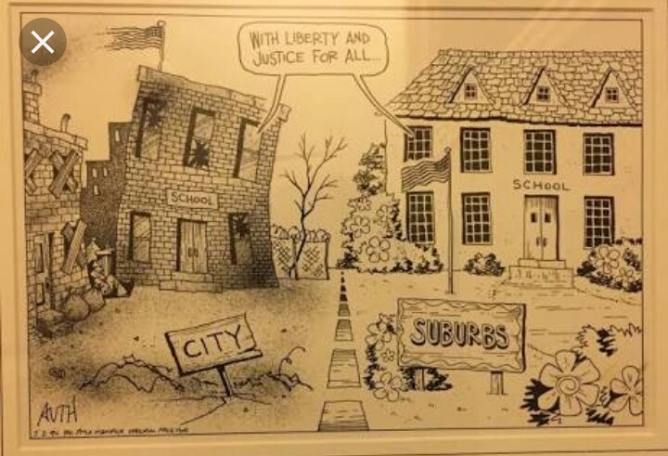

In addition to the effect on educational experience, the segregation o education had immense psychological and emotional damage on the black children; because it communicated that they were not like white children. This affected their attitudes towards education and towards life, giving up hope and their desires that they saw as unattainable in a system where privileges were accorded on the basis of skin color (Caliver, 1956).
Further, the segregation proved very expensive for the poor southern states. If equality was to be achieved even despite the segregation as those in powers insinuated, then, it means that the little federal funds had to be directed to the black schools that were underfunded, something that would deplete the resources for other public services. The authorities thus continued to neglect the black school using lack of funds as a justification (Caliver, 1956).
Benjamin Mays looks at segregation in higher education during the same and concluded that it is ironical that institutions of higher education can purport to operate on the basis of segregation. He says that, the institutions of higher learning are where people are supposed ot learn the truth so that this frees their minds. It is therefore contradictory that what the institutions teach can hardly be described as equal (Mays, 1949).
Mays recounts how black and white students would use the same facilities and the same instructions for their classes yet they would be taught in different classes and even when they sat in the same class, the black students sat in their space and the white students in a different space. He says that this was the separate but equal justification that was offered by this system of education and goes on to show why this was not right (Mays, 1949).
Mays say that for an education to be equal, it requires more than having the same teachers and using the same facilities. He says that equality instead is about having the freedom to interact with everyone in the educational system and getting a wholesome learning experience, one that is not only contained in one place like in the ghetto. It is only when black students have exposure beyond their poor neighborhoods that education will make sense and helps them to make better decisions (Mays, 1949).
Mays says that the biggest problem with segregation is that only the African Americans get segregated, something which other literature has indeed confirmed. Even other minorities are not discriminated against as the black people are. This means that the society is very deliberate in these efforts of segregation, possibly driven by the supremacist ideologies of seeing the black people are inferior and not worth of any privileges (Mays, 1949). This is probably what has worked to keep the black person oppressed, poor and unable to access the same opportunities like other groups in America.
In 1954, the Brown versus Board of Education case came to undo segregation in education, arguing that even if the different schools have equal amenities, segregation was morally and constitutionally wrong and that it ought to be stopped immediately. This, for a moment, one would think it would give relief to black learners as now they would have opportunities to have the same education experiences with students of other races. However, the reality is farther from this expectation.
Donna Ford and Robert King, (2014), show that black students continue to be underrepresented in the gifted education school programs while the white and Asian children are overrepresented, which they interpret as covert segregation of black learners. They say that the requirement of entry into the program is high IQ as determined by test scores, creative thinking, and demonstration of leadership qualities among other qualities should have to be determined viable for the gifted schools.
Ford and King use data from 2006, across 2009 and up to 2011 to show the underrepresentation of black learners in gifted schools. In 2006 for instance, they show that black learners made up 17.3 percent of the school districts yet they were only 9.15 percent in the gifted schools. White children made up 54.6 percent of school district yet they were 67.6 percent of those in gifted schools. In 2009 the trend is the same where black students were 16.7 percent of school districts yet only 9.9 percent were enrolled in gifted schools while Asian and white children were overrepresented. In 2011, the trend had not yet changed where black students made up 19 percent of learners in school districts yet they have only 10 percent in the gifted schools (Ford & King, 2014). The underrepresentation of the black students across the years is obvious and for the black students living in this day and age, the Brown versus Board of Education pivotal decisions has not made any sense.
Ford and King argue that from these figures, it is clear that social stratification, racism, racial prejudice and racial supremacy is at the heart of the inequalities that are observed in education today. They say that white people, in this case, the teachers, the decision and the policy makers have continued to hold on to the belief that white students should be given better opportunities while the black ones should continue being trampled. They say that the underrepresentation of black students in the gifted schools is a function of white privilege that is embedded in the larger cultural, political and economic ideologies that seeks to keep the white man at the top (Ford & King, 2014).
The underrepresentation of the black students in the gifted school programs for instance, Ford and King show, are likely to feed into the social inequalities that black people have to contend with every day. Denying the black students the opportunities o the gifted programs hinders the development of their abilities and academic achievement which then goes on to affect their economic life trajectories. They are likely to underperform in school drop out and have limited economic opportunities and this is a vicious cycle that has become hard to break (Ford & King, 2014).
Is it the racial segregation or the inequality educational resources that matter in the debate about educational segregation and how it produces educational inequality is the question that Sean Reardon asks in his article of looking at the relationship between school segregation and the resultant achievement gaps (Reardon, 2016).
Reardon says that the racial impacts are not the only effects that school segregation that black children suffer as the court in Brown versus Board of Education implied when it ruled that even if the material conditions of the schools improved, segregation would still largely harm black children who could not get access to white schools (Reardon, 2016).
The socio-economic conditions of the students in a school are a very important factor that determines the academic achievement of the learner. First school neighborhoods and quality are interlinked. A school draws on the resources of its neighborhoods. A poor school thus will have poor resources to draw from thus reducing the educational qualities of the poor children that attend the school. This is the opposite of schools in rich neighborhoods where the students have more resources to utilize in their educational experience thus resulting in the difference in educational outcomes (Reardon, 2016).
The other factor of importance in school segregation is focus and quality of instruction. Schools in rich neighborhoods are likely to attract high quality teachers which improve their instructional focus. Further, such schools are also likely to have the support of the parents and when there are combined efforts, the children are likely to perform better (Reardon, 2016).
Further, the social norms of a school affect the performance of the learners therein. In high socioeconomic neighborhoods, children are likely to be motivated by the success of the community, and such schools are likely to have high expectations of their learners thus encouraging them to perform better while in the poor neighborhood schools, the learners are demotivated by a culture of failure (Reardon, 2016).
Reardon in this research finds that minority group learners such as black and Hispanic children attending schools in white neighborhoods perform better than when they attend schools where a majority of the student population is poor. In addition, white children attending schools where a majority of the students are poor are negatively affected in their studied thus answering the question that it is not racial segregation per se that matters but the neighborhood conditions and the unequal schooling that is resultant of the segregation (Reardon, 2016).
The issue of segregation of education in America is complex and needs not be solved by eliminating only one method of segregation and assuming that this will solve all other issues. As in the words of Mays, desegregating schools will not solve all other racial issues there are ins society (1949), but it does help to free up the minds of the black and other minority children.
Following a change in choice of schools in Stockholm upper secondary schools, Martin Soderstrom finds that while the reform was meant to eliminate neighborhood segregation by giving black and other minority learners the chance to attend high end schools, the schools again become segregated by family background and socio-economic status (Soderstrom, 2010).
Soderstrom for instance finds that even when children in the ethnic minority groups had the good grade to attend the high end performing schools, some of the schools were far away and called for expensive commuter costs. Thus some well-performing students were forced to attend the poor schools in their neighborhoods. The schools thus became segregated not by ethnic groups but by socio-economic ability (Soderstrom, 2010).
Further, as Soderstrom shows, the admission reform did not change the patterns of schools. This is because, the move only saw more private established for the white rich children who could not make it to the high end schools probably because the schools reached their cuts. Thus, this reform only prompted other segregated structures to come up which then shows that tackling the issue of school segregation is not that easy as it may seem (Soderstrom, 2010).
Segregation of education in America, as is seen from the above literature is something that is deep, having its roots in the era of slavery and is a conspiracy to keep some sections of the society impoverished and without an education, which then perpetuates a cycle of poverty for the black population that is unable to participate effectively in the society. It was dealt with during the civil rights period and even today the American society is still grappling with it. Even though it is obvious that desegregation of schools will not solve all the racial inequality issue in the society, it is a great place to start so that all learners regardless of their ethnicity and their socio-economic position can have a wholesome educational experience which they can use to make better their lives in the future.

References
Caliver, A. (1956). Segregation in American education: an overview. The Annals of the American Academy of Political and Social Science, 134, 17-25.
Ford, D. Y., & King, R. A. (2014). No blacks allowed: segregated gifted education in the context of Brown v. Board of Education. The Journal of Negro Education, 83(3), 300-310.
Mays, B. E. (1949). Segregation in higher education. Phylon (1940-1956), 10(4), 401-406.
Reardon, S. F. (2016). School segregation and racial academic achievement gaps. The Russell Sage Foundation Journal of the Social Sciences, 2(5), 34-57.
Soderstrom, M. (2010). School choice and segregation: evidence from an admission reform. Scandinavian Journal of Economics, 112(1), 55-76.

